**Reproductive System**

**Pelvic Inflammatory Disease**

* It is a gynecological problem characterised by inflammatory conditions of pelvic cavity that may begin with cervicitis and may involve uterus (endometritis), pelvic peritoneum, fallopian tube (salpingitis), ovaries (oophoritis) or pelvic vascular system.

**Etiology:**

* Common cause is bacteria, e.g., gonorrheal organisms (*Neisseria gonorrhoeae*), *Chlamydia trachomatis, Streptococci, Staphylococci* and other pus producing pyogens.
* Some viruses e.g., CMV (Cytomegalo virus)

**Pathophysiology:**

* *Gonococcal* and *staphylococcal* organisms spread along the uterine endometrium to fallopian tubes, where they cause an acute **salpingitis** (inflammation of fallopian tube).
* The tubes become partially **occluded** and may drain **pus**, **leukocyte**, and other **debris** into pelvic cavity, causing pelvic **peritonitis** or material may form a pocket around the ovary causing **tubo-ovarian abscess**.
* *Streptococci* spread similarly except they tend to travel via the uterine and cervical **lymphatics** across the parametrium to tube or ovaries. There they may cause **pelvic** **cellulitis** and sometimes **thrombophlebitis** of the major pelvic veins, with the risk of the development of embolism.
* Another route of infection is from pelvic cavity itself. Organisms such as *E. coli* may be extruded from a ruptured **viscus**, causing **peritonitis**

**Clinical features:**

* Vaginal discharge
* Dyspareunia
* Lower abdominal pelvic pain and tenderness that occurs after menses
* Pain may be aggravated with defecation and voiding
* Occasionally vaginal bleeding
* On pelvic examination, intense tenderness may be noted

**Other generalized sign and symptoms**

* Fever
* General malaise
* Anorexia
* Nausea
* Headache
* Possibly vomiting

**Complications of PID:**

* **Peritonitis**
* **Intestinal obstruction** due to adhesion between small bowel and pelvic organ
* **Bacteraemia**, which may produce endocarditis, meningitis and suppurative arthritis
* **Infertility**

**Management:**

* **Broad** **spectrum antibiotic therapy** – usually a combination of ceftriaxone (ceftin), azithromycin or doxycycline.
* Intensive therapy includes **bed rest**, **intravenous fluids** and **intravenous antibiotics.**
* **Treatment of sexual partner** is necessary to prevent reinfection.

**Tumor of Ovary**

**Structure of Ovaries**

* Ovaries, a pair of female gonads (sex organs), reside in the pelvic part of the abdomen on either sides of the uterus. Ovaries produce **ova** and **estrogen** (female sex hormones).
* The ovaries have two functions: **production** & **ovulation of oocytes** and **production** & **secretion of hormones**.
* The ovary is attached to the broad ligament by a short fold of **peritoneum**, called **mesovarium** (or ligament of the ovary), through which vessels and nerves pass to the ovary and enter it at the hilus of the ovary.

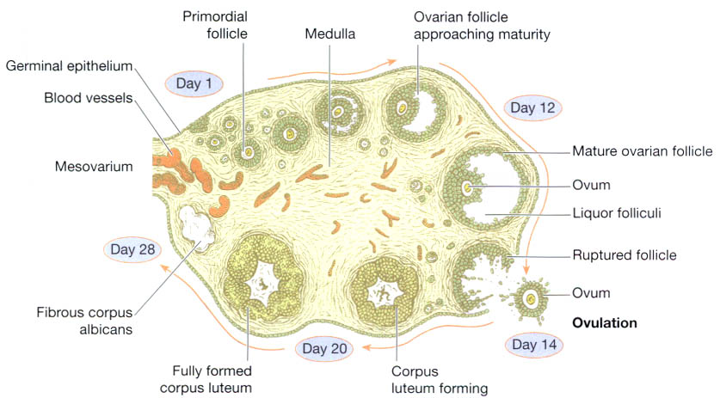

**Fig: A section of an ovary showing the stages of development of one ovarian follicle.**

***Histologically,*** the ovarian structure consists of covering by coelomic epithelium, outer cortex and inner medulla.

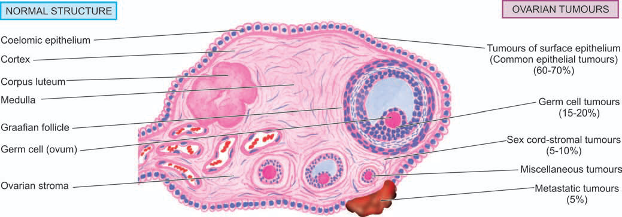

**Fig: Structure of the ovary to illustrate origin of ovarian tumours.**

* The ovary is third most common site of primary malignancy in the female genital tract, preceded only by endometrial and cervical cancer.
* Both benign and malignant tumours occur in the ovaries.

**ETIOPATHOGENESIS**

* **Mostly unknown**
* However, a few risk factors have been identified as under:
  1. **Nulliparity:** higher incidence of ovarian cancer in unmarried women and married women with low or no parity.
  2. **Heredity:** family history of ovarian or breast cancer.
  3. **Complex genetic syndromes:** e.g. *Lynch syndrome (*colorectal cancer)associated with increased risk of ovarian cancer, etc.

**Clinical Features**

* In general, **benign ovarian tumours** are more common, particularly in young women between the age of **20 and 40 years**, and account for 80% of all ovarian neoplasms.
* Primary **malignant ovarian tumours** are more common in older women between the age of **40 and 60 years**.
* Causes **abdominal discomfort** and **distension**.
* **Urinary tract** and **gastrointestinal tract symptoms** are frequently associated due to compression by the tumour.
* **Ascites** is common in both benign and malignant ovarian tumours.
* **Menstrual irregularities** may or may not be present.
* Some ovarian tumours are **bilateral**.
* Malignant tumours usually **spread** beyond the ovary to other sites before the diagnosis is made.

**Classification**

* A simplified classification proposed by the WHO with minor modifications has been widely adopted.
* According to this classification, ovarian tumours arise from normally-occurring cellular components of the ovary.
* **Five major groups have been described:**
  + 1. Tumours of surface epithelium (common epithelial tumours)
    2. Germ cell tumours
    3. Sex cord-stromal tumours
    4. Miscellaneous tumours
    5. Metastatic tumors

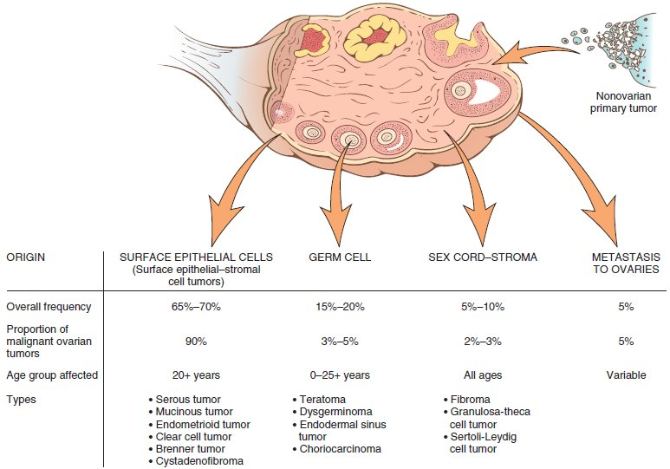

**I. Tumours of Surface Epithelium (Common Epithelial Tumours)**

* Tumours derived from the **surface (coelomic) epithelium** called common epithelial tumours form the largest group of ovarian tumours.
* The common epithelial tumours are of 3 major types—***serous****,* ***mucinous*** and***endometrioid.***
* Depending upon the aggressiveness, the surface epithelial tumours are divided into 3 groups: *clearly benign, clearly malignant, and borderline* (or *atypical proliferating or low-grade) malignant tumours.*

1. **Clearly benign tumours –** are lined by a **single layer** of well-oriented columnar epithelium.
2. **Clearly malignant tumours –** have anaplastic epithelial component**, multi-layering**, loss of basal polarity and stromal invasion.
3. **Borderline (atypical proliferating) tumours –** absence of stromal invasion, **stratification** (**2-3 layers**) of the epithelial cells but generally maintained basal polarity of nuclei, moderate nuclear abnormalities, and some mitotic activity.

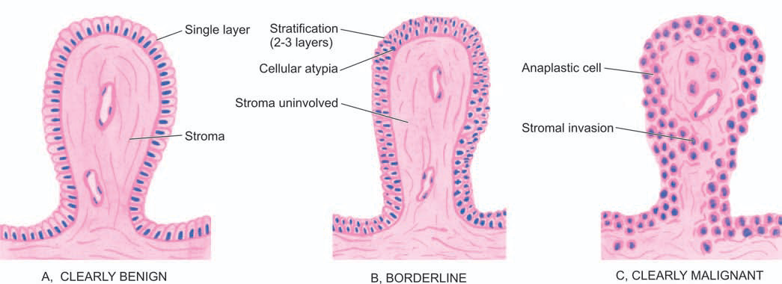

Fig: Diagrammatic representation of general histologic criteria to distinguish benign, borderline (atypical proliferating) and malignant surface epithelial tumours of the ovary.

**Serous Tumours:**

presence of **clear**, **watery**, **serous** **fluid** in these predominantly cystic tumours.

**Morphologic Features.**

* **Grossly,** benign, borderline and malignant serous tumours are **large** (above 5 cm in diameter) and **spherical** **masses**.
* Small masses are generally **unilocular** while the larger serous cysts are **multiloculated**
* *Malignant serous tumours* may have solid areas in the cystic mass.
* **Intracystic papillary projections** may be present

**Histologically, the features are as follows:**

1. **Serous cystadenoma**

* lined by **columnar epithelium**, **ciliated** and resembles **tubal** **epithelium**.
* microscopic **papillae** may be found

1. **Borderline (atypical proliferating) serous tumour**

* **stratification** (2-3 layers) of benign serous type of epithelium.
* **detachment of cell clusters**, moderate features of malignancy and **absence of stromal invasion**.

1. **Serous cystadenocarcinoma**

* **multilayered** malignant cells which show **loss of polarity**, presence of solid sheets of **anaplastic epithelial cells** and definite **evidence of stromal invasion**.
* **papillae formations** and may be associated with **psammoma** **bodies**

**Mucinous Tumours**

**Morphologic Features**

* **Grossly,** mucinoustumours are much **larger** than serous tumours. They are smooth-surfaced cysts with characteristic **multiloculations** containing **thick** and **viscid** **gelatinous** **fluid**
* **Histologically,** the most distinctive feature is the characteristic tall columnar non-ciliated epithelium.

**Other features are as under:**

1. **Mucinous cystadenoma**

lined by a **single layer of cells** having **basal nuclei** and **apical mucinous vacuoles**.

1. **Borderline (atypical proliferating) mucinous tumour**

**stratification** (usually 2-3 cell thick) of typical epithelium **without stromal invasion**.

1. **Mucinous cystadenocarcinoma**

**malignant epithelium**, at places forming solid sheets, **papillary formation**, adenomatous pattern and **infiltration into stroma** with or without pools of mucin.

**Endometrioid Tumours**

**Morphologic Features**

***Grossly,*** these tumours are partly **solid** and partly **cystic** and may have foci of **haemorrhages**, especially in benign variety.

***Histologically,***

* typical glandular pattern
* foci of squamous metaplasia.
* papillary pattern and foci of serous and mucinous carcinoma

**Clear Cell (Mesonephroid) Tumours**

**Morphologic Features**

**Grossly,** these tumours are large, usually unilateral, partly solid and partly cystic.

***Histologically,*** characterised by tubules, glands, papillae, cysts and solid sheets of tumour cells.

**Brenner Tumour**

**Morphologic Features**

**Grossly,** is typically solid, yellow-grey, firm mass of variable size.

**Histologically,**

consists of nests, masses and columns of epithelial cells, scattered in fibrous stroma of the ovary.

Cells are ovoid in shape, having clear cytoplasm, and nuclei with characteristic nuclear groove called ‘coffee-bean’ nuclei.

**II. GERM CELL TUMOURS**

Ovarian germ cell tumours arising from germ cells which produce the female gametes (i.e. ova) account for about 15-20% of all ovarian neoplasms.

**Teratomas**

* Teratomas are tumours composed of different types of tissues derived from the **three germ cell layers—ectoderm**, **mesoderm** and **endoderm**, in different combinations.
* Tumours arise from a single germ cell (ovum) after its first meiotic division.
* Teratomas are divided into 3 types:
  + 1. mature (benign),
    2. immature (malignant), and
    3. monodermal or highly specialised teratomas.

**i. Mature (Benign) Teratoma**

* **Grossly,** characteristically a unilocular cyst, **10-15 cm** in diameter
* On sectioning, the cyst is filled with paste-like **sebaceous secretions** and **desquamated** **keratin**. The cyst wall is thin and opaque grey-white.
* **Microscopically,** the lining of the cyst wall by **stratified squamous epithelium** and its adnexal structures such as **sebaceous glands**, **sweat glands** and **hair follicles**

**ii. Immature (Malignant) Teratoma**

***Grossly,*** unilateral solid mass which on cut section shows characteristic areas of **haemorrhages**, **necrosis**, **tiny** **cysts** and heterogeneous **admixture** of various tissue elements.

***Microscopically,*** parts of the tumour may show **mature tissues**, while most of it is composed of **immature tissues** having an embryonic appearance.

**iii. Monodermal (Specialised) Teratoma:**

Monodermalor highly specialised teratomas are rare.

**III. SEX CORD-STROMAL TUMOURS**

Sex cord-stromal tumours of the ovaries comprise 5-10% of all ovarian neoplasms. They arise from specialised **ovarian** **stromal cells** of the developing gonads. Thus, these include tumours originating from **granulosa cells, theca cells** and **Sertoli-Leydig cells**.

**IV. MISCELLANEOUS TUMOURS**

**Lipid Cell Tumours**

appears as **soft yellow** or **yellow-brown nodules** which on histologic examination are composed of **large lipid laden cells**.

**Gonadoblastoma**

occurring exclusively in gonads, more often in phenotypic females and in hermaphrodites.

**V. METASTATIC TUMOURS**

* Metastasis may occur by **lymphatic** or **haematogenous route** but direct extension from **adjacent organs** (e.g. uterus, fallopian tube and sigmoid colon) too occurs frequently.
* Most common primary sites are: carcinomas of the breast, genital tract, gastrointestinal tract (e.g. stomach, colon appendix, pancreas, biliary tract) and haematopoietic malignancies.

**Krukenberg Tumour**

* ***Grossly,*** Krukenberg tumour forms **rounded or kidney shaped** firm large masses in both ovaries. Cut section shows grey-white to yellow firm **fleshy tumour** and may have areas of **haemorrhage** and **necrosis**.
* ***Microscopically***, it is characterised by the presence of **mucus-filled signet ring cells** which may lie singly or in clusters.

**CERVICITIS**

* Inflammation of the cervix uteri or neck of the womb
* May present in all women
* Cervicitis may be specific or nonspecific, acute or chronic.
  + ***Specific cervicitis*** may be caused by tuberculosis, syphilis*,* lymphogranuloma venereum, Chlamydia and chancroid.
  + ***Nonspecific cervicitis*** is more frequent and is generally divided into **acute** and **chronic** **forms**, the latter being quite common.

**Acute Cervicitis:**

* Acute cervicitis is usually associated with **gonococcal** infection. Other causes are **primary** **chancre** and infection with **herpes simplex**.
* ***Grossly,*** the cervix shows **red** and **edematous** **mucosa**.
* ***Histologically,*** there is **infiltration** of the subepithelial and periglandular tissue with **neutrophils**, and there is **oedema** and **congestion**.
* The **mucosa** may be **ulcerated** and **haemorrhagic**.

**Chronic Cervicitis:**

* The most common organisms are the normal mixed vaginal flora that includes ***Streptococci****,* ***Enterococci***(e.g. ***E. coli***) and ***Staphylococci***.
* Other infecting organisms include **gonococci**, ***Trichomonas******vaginalis****,* ***Candida******albicans***and **herpes simplex**.
* Predisposing factors are sexual intercourse, trauma of childbirth, instrumentation and excess or deficiency of oestrogen.

***Grossly,*** there is **hyperaemia**, **oedema** and **granular** **surface**.

***Histologically,***

* Characterised by extensive subepithelial inflammatory **infiltrate of lymphocytes, plasma cells, large mononuclear cells** and **a few neutrophils**.
* Formation of lymphoid follicles termed *follicular cervicitis.*
* Surface epithelium may show squamous metaplasia and may develop surface **keratinisation** and **hyperkeratosis**, so called *epidermidisation.*

**TUMOURS OF CERVIX**

* Both benign and malignant tumours are common in the cervix.
* May include cervical dysplasia and carcinoma *in situ* (**cervical intraepithelial neoplasia, CIN**), currently termed **squamous intraepithelial lesions (SIL).**
* Benign tumours of the cervix consist most commonly of **cervical polyps**.
* The most common malignant tumour is **squamous carcinoma** of the cervix.

**Cervical Polyps**

* Localised benign **proliferations of endocervical mucosa**.
* They are found in 2-5% of adult women and produce irregular vaginal spotting.

**Morphologic Features**

* ***Grossly,*** a small (up to **5 cm** in size), bright red, fragile growth which is frequently **pedunculated** but may be **sessile**.
* ***Microscopically,*** covered with endocervical epithelium which may show **squamous metaplasia**. The **stroma** is composed of **loose and edematous fibrous tissue** with variable degree of inflammatory infiltrate and contains dilated **mucus secreting endocervical glands.**

**Microglandular Hyperplasia**

* Microglandular hyperplasia is a benign condition of the cervix in which there is closely packed **proliferation of endocervical glands without intervening stroma**.

**Squamous Intraepithelial Lesion (SIL) (Cervical Intraepithelial Neoplasia, CIN)**

**Morphologic Features**

***Grossly,*** changes begin at the **squamocolumnar junction** or transitional zone.

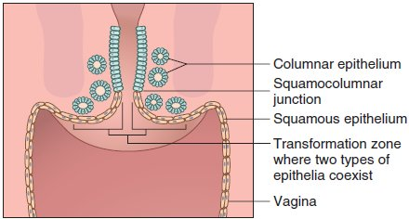

***Histologically,*** dysplastic cells are distributed in the **layers of squamous epithelium** for varying thickness, and accordingly graded as **mild**, **moderate** and **severe** **dysplasia**, and **carcinoma *in situ****.*

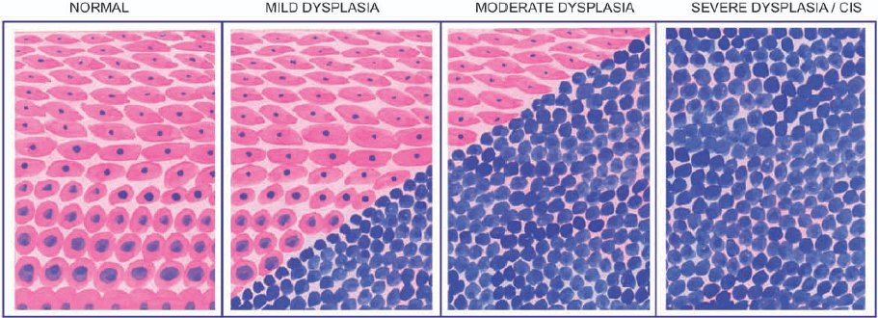



* In ***mild dysplasia*** *(CIN-1),* the abnormal cells extend up to one-third thickness from the basal to the surface layer;
* In ***moderate dysplasia*** *(CIN-2)* up to two-thirds;
* In ***severe dysplasia*** *(CIN-3),* these cells extend from *75-*90% thickness of epithelium;
* In **carcinoma *in situ*** *(included in CIN-3),* the entire thickness from the basement membrane to the surface shows dysplastic cells.
* The **atypical cells migrate** to the surface layers from where they are shed off (**exfoliated**) into vaginal secretions in **Pap smear**.

**Invasive Cervical Cancer**

**Morphologic Features**

***Grossly,*** 3 types of patterns: **fungating**, **ulcerating** and **infiltrating**. The fungating or exophytic pattern appearing as **cauliflower-like growth** infiltrating the adjacent vaginal wall is the most common type.

Arises from the **squamocolumnar** **junction**. Characterised by **widespread** destruction and infiltration into adjacent structures including the urinary bladder, rectum, vagina and regional lymph nodes. **Distant metastases** occur in the lungs, liver, bone marrow and kidneys.

***Histologically,*** the following patterns are seen:

1. **Epidermoid (Squamous cell) carcinoma. non-keratinising** large cell type and has better prognosis and **keratinising** **epidermoid carcinoma**.
2. **Adenocarcinoma.** well-differentiated **mucus secreting adenocarcinoma**, or clear cell type containing **glycogen** but no mucin.

**Leiomyoma:**

* Benign smooth muscle tumors, or *leiomyomas,* are common, well-circumscribed neoplasms that can **arise from smooth muscle cells** anywhere in the body but are encountered most commonly in the **uterus** and the skin.
* Leiomyomas or fibromyomas, commonly called ***fibroids***by the gynaecologists, are the most common uterine tumours of smooth muscle origin, often admixed with variable amount of **fibrous tissue component**.
* About 20% of women above the age of 30 years harbour uterine myomas of varying size.
* Vast majority of them are benign and cause no symptoms.
* Symptomatic cases may produce **abnormal uterine bleeding, pain, symptoms due to compression of surrounding structures and infertility**.
* The **cause** of leiomyomas is **unknown** but the possible stimulus to their proliferation is **estrogen**.
* This is evidenced by increase in their size in pregnancy and high dose estrogen-therapy and their regression following menopause and castration.
* Other possible factors implicated in its etiology are human growth hormone and sterility.

**MORPHOLOGIC FEATURES**

* Leiomyomas are most frequently located in the uterus where they may occur within the **myometrium** *(****intramural*** *or interstitial),* the **serosa** *(****subserosal****),* or just underneath the **endometrium** *(****submucosal****).* Subserosal and submucosal leiomyomas may develop pedicles and protrude or stick out as pedunculated myomas. Leiomyomas may involve the cervix or broad ligament.

***Grossly,***

* Irrespective of their location, leiomyomas are often **multiple, circumscribed, firm, nodular, grey-white masses of variable size**.
* On cut section, they exhibit characteristic **whorled pattern (Fig 1).**

***Histologically,***

* They are essentially composed of 2 tissue elements—**whorled bundles of smooth muscle cells** admixed with variable amount of connective tissue.
* The smooth muscle cells are uniform in size and shape with abundant cytoplasm and central oval nuclei **(Fig 2).**

**BREAST TUMOURS**

* Tumours of the female breast are common and clinically significant but are rare in men.
* Among the important benign breast tumours are **fibroadenoma**, **phyllodes** **tumour** (cystosarcoma phyllodes) and **intraductal** **papilloma**.
* Carcinoma of the breast is an important malignant tumour which occurs as non-invasive and invasive cancer with its various morphologic varieties.

**Fibroadenoma**

* most common benign neoplasm of the female breast.
* composed of **fibroblastic stroma** and **epithelium-lined glands**; however, only the **stromal cells** are **clonal** and truly **neoplastic**.
* typically appear in young women with a peak incidence in the third decade of life.
* They usually manifest as **solitary**, **discrete**, **mobile masses**.

**MORPHOLOGY**

* The fibroadenomas form **discrete masses, 1 cm to 10 cm in diameter** and of firm consistency
* A cut section shows a uniform **tan-white color**, scattered by softer yellow-pink fragment representing the glandular areas.
* Histologic examination shows a **loose fibroblastic stroma** containing **ductlike**, **epithelium-lined spaces of various shapes and sizes**.
* Two types of pattern:
  + **Pericanalicular fibroadenoma**: the ductal spaces are **open**, **round to oval**, and fairly regular
  + **Intracanalicular fibroadenoma**: ductual spaces are compressed by extensive **proliferation** of the **stroma**, appear as slits or irregular, star-shaped structure

**Phyllodes Tumour (Cystosarcoma Phyllodes)**

* An uncommon **bulky breast tumour** with **leaf-like** gross appearance (*phyllodes=*leaf-like)
* Most patients are between 30 to 70 years of age.
* **Morphologic Features**
* **Grossly**, the tumour is generally **large**, **10-15 cm** in diameter, round to oval and less fully encapsulated than a fibroadenoma.
* The cut surface is grey-white with **cystic cavities**, areas of **haemorrhages**, **necrosis** and **degenerative changes**

**Histologically,** composed of an extremely **hypercellular stroma**, accompanied by **proliferation of benign ductal structures**.

The histologic criteria used to distinguish benign, borderline and malignant categories of phyllodes tumour are as under:

* + frequency of **mitoses**;
  + cellular **atypia**;
  + **cellularity**; and
  + **infiltrative margins**.

**INTRADUCTAL PAPILLOMA**

* benign papillary tumour occurring most commonly in a **lactiferous duct** or **lactiferous** **sinus** near the nipple.
* Clinically, it produces **serous nipple discharge**. It is most common in 3rd and 4th decades of life.
* **Morphologic Features**
* ***Grossly,* solitary, small, less than 1 cm in diameter**, commonly located in the major mammary ducts close to the nipple
* ***Histologically,*** characterised by **multiple papillae** having well developed **fibrovascular stalks attached to the ductal wall** and covered by **benign cuboidal epithelial cells** supported by myoepithelial cells.

**Infiltrating (Invasive) Duct Carcinoma**

* Infiltrating duct carcinoma is the classic breast cancer and is the most common histologic pattern accounting for 70% cases of breast cancer.
* They are found more frequently in the left breast, often in the upper outer quadrant.

**Morphologic Features.**

***Grossly,*** the tumour is **irregular**, **1-5 cm** in diameter, **hard cartilage-like mass** that cuts with a **grating** **sound**.

* The sectioned surface of the tumour is **grey-white to yellowish** with **chalky streaks** and often extends irregularly into the surrounding fat.

***Histologically,*** A variety of histologic features commonly present are as under:

1. **Anaplastic** **tumour cells** forming **solid** **nests**, **cords**, poorly-formed glandular structures and some intraductal foci.
2. **Infiltration** by these patterns of **tumour cells into diffuse fibrous stroma and fat.**
3. **Invasion** into perivascular and perineural spaces as well as lymphatic and vascular invasion.

**Benign Nodular Hyperplasia (BNH) Or Benign Enlargement Of Prostate (BEP)**

* Non-neoplastic tumour-like enlargement of the prostate, commonly termed benign nodular hyperplasia (BNH) or benign enlargement of prostate (BEP), is a **very common** condition in men and considered by some as **normal ageing process.**
* It becomes increasingly more frequent above the age of 50 years and its incidence approaches 75-80% in men above 80 years.
* However, symptomatic BEP producing **urinary tract obstruction** and requiring **surgical treatment** occurs in 5-10% of cases only.

**Etiology:**

* The cause of BEP has **not been fully established**.
* However, a few etiologic factors such as:
  + *Endocrinologic,*
  + *Inflammation,*
  + *Arteriosclerosis, etc.*

* **Endocrine** basis for hyperplasia has been more fully investigated and considered a strong possibility in its genesis.
* A plausible hypothesis suggested is that there is synergistic **stimulation** of the prostate by both hormones—the ***oestrogen***acting to sensitise the prostatic tissue to the growth promoting effect of ***dihydroxy-testosterone***derived from plasma testosterone.

**Morphologic Features.**

***Grossly,***

* Enlarged prostate is nodular, smooth and firm and weighs **2-4 times** its normal weight i.e. may weigh up to **40-80 gm**.
* **Hyperplasia** is predominantly of the **glandular** or **fibromuscular** **tissue**.
* In **primarily glandular BEP** the tissue is yellow-pink, soft, **honey-combed**, and **milky fluid exudes**, whereas in mainly ***fibromuscular BEP*** the cut surface is firm, **homogeneous** and **does not exude milky fluid**.

***Histologically,*** in every case, there is hyperplasia of all three tissue elements in varying proportions—glandular, fibrous and muscular

* **Glandular hyperplasia.** The lining epithelium is **two-layered**: the inner tall **columnar** mucus secreting with poorly-defined borders, and the outer **cuboidal** to flattened epithelium with basal nuclei.
* **Fibromuscular hyperplasia** when present as dominant component appears as **aggregates of spindle cells.**
* May also include foci of **lymphocytic aggregates**, small areas of **infarction**, and foci of **squamous** **metaplasia**.

**Clinical Features**

* Frequency
* Nocturia
* Difficulty in micturition
* Pain
* Haematuria
* Patients present with acute retention of urine requiring immediate catheterisation.

**Complications:**

* Urethral obstruction
* Bladder (e.g. hypertrophy, cystitis),
* Ureter (e.g. hydroureter)
* Kidneys (e.g. hydronephrosis)